Assessment Schedule – 2016

Physics: Demonstrate understanding of wave systems (91523)

Evidence Statement
NØ | N1 | N2 | A3 | A4 | M5 | M6 | E7 | E8
0 | 1a | 2a | 3a | 4a OR 1a + 1m | 2a + 1m | 1a + 2m | 1a + 1m + 1e | 1a + 2m + 1e

Q | Evidence | Achievement | Merit | Excellence
ONE  (a) | 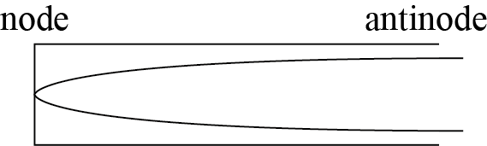 | Correct diagram and labels.
(b) | The first pipe produces a lower frequency, so it has a longer wavelength and a longer pipe length.  The wave speed is constant.  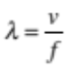 so a lower frequency means a longer wavelength.  The wavelength of a standing wave in a pipe is proportional to the pipe length. | Lower frequency pipe / 350 Hz / first pipe is longer  AND one of  correct description of relationship between frequency and wavelength  OR  Longer pipes have longer wavelengths | Statement relating wavelength to pipe length.  AND  Statement relating wavelength to frequency to explain that the first pipe is longer.
(c) | The phenomenon is called beating (beats).  The two pipes produce similar but different frequencies.  At one time, two waves arrive in phase and add constructively (loud), a short time later two waves arrive out of phase and add destructively (quiet). | Beating occurs / beats occur. AND  ONE of:  Links loudness to phase or type of interference | Explanation linking phase and interference to loudness changing over time to produce beats

(d) | 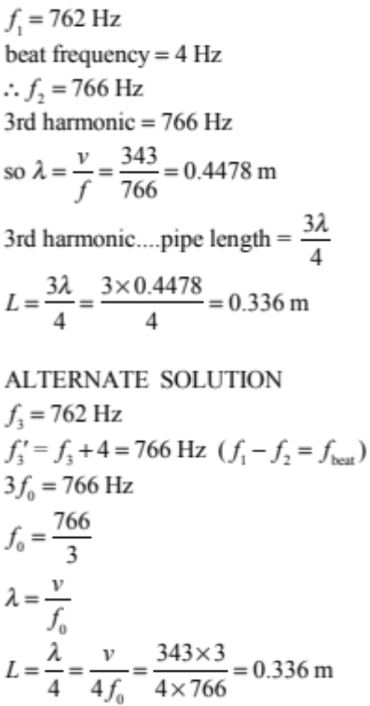 | Correct value for 2nd pipe frequency. | Correct value for 2nd pipe frequency AND realisation that 2nd pipe contains 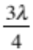.  OR  Correct calculation of L with incorrect frequency. | Correct answer and working.

Q | Evidence | Achievement | Merit | Excellence
TWO  (a) | At X, the plane is moving towards Mike.  Since the plane is moving, the centre of each new wavefront is slightly displaced to the right. As a result, the wavefronts bunch up on the right side, this reduces the wavelength.  Shorter wavelength means a higher frequency  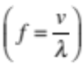 v is constant. | The plane is catching up to waves already emitted.  OR  Shorter wavelength  OR  higher frequency. | Correct answer linking higher frequency to shorter wavelength with reason.
(b) | At Y, the frequency heard is “normal” (185 Hz). | Answer correct.
(c) | As the plane accelerates to the right:  This will cause the wavelength of the waves behind the plane to gradually increase.  AND the frequency will gradually decrease. | Frequency gradually decreases.  OR  Wavelength gradually increases.  (General description of the Doppler effect for a receding source can be used as a replacement for 2a.) | Frequency gradually decreases AND  full explanation.
(d) | 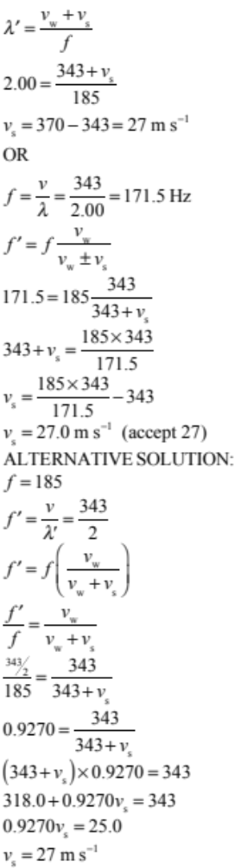 | Correct frequency (171.5 Hz). | Correct substitution into Doppler equation.  OR  Correct Doppler calculation using incorrect frequency.  OR  Correct Doppler calculation except for –sign in equation.  (produces –27 m s^{–1}) | Correct answer with correct working.  OR  –27 m s^{–1} with explanation that the negative means the plane is moving away.

Q | Evidence | Achievement | Merit | Excellence
THREE  (a) | 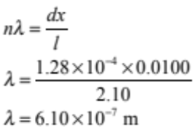 | Correct formula and substitution.
(b) | 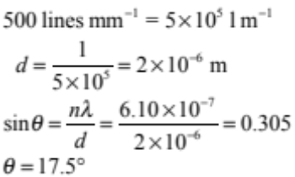 | Correct calculation of d.  OR  Correct use of equation with incorrect d. | Correct formula, substitution, answer and units.
(c) | 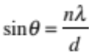  So if wavelength decreases and d is constant, sinθ will decrease,(so θ will decrease, so antinodes / bright spots get closer.  OR  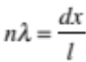 , so if λ decreases, x will decrease, meaning the antinodes will get closer.  OR  If the wavelength decreases, then the path difference to the antinodes will decrease. This will cause the angle between the antinodes to decrease, and the bright spots to get closer together. | Antinodes get closer.  OR  Describes relationship between λ and θ or x. | Antinodes get closer  AND one of:  - Explanation using either equation.  - Correctly uses path difference creating constructive interference explanation.
(d) | White light contains all the wavelengths of visible light. All the wavelengths diffract as they pass through the diffraction grating and spread out through 180º. Each slit acts as a point source of all the wavelengths of light in the visible spectrum.  Waves from each slit interfere with waves of the same wavelength from other slits. Interference is predominantly destructive due to the many closely spaced sources.  In the dark region all visible wavelengths are experiencing destructive interfere. Only wavelengths invisible to the eye constructively interfere. No light is seen.  Individual colours are seen where constructive interference is occurring for that colour but destructive interference is occurring for all other colours. The red antinode is at a larger angle than the violet, because the red light has a longer wavelength. As shown by 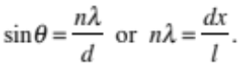  The centre of the pattern is white because there is a central antinode for all colours. Here each wavelength of light constructively interferes with other sources of the same wavelength. The resulting white light is a composite maximum of all the colours. | White seen is central antinode.  OR different colours have 1st antinode at different angle.  OR different colours have different wavelengths.  OR dark regions are nodes (attributed to destructive interference). | Correct explanation for:  White in centre / middle caused by antinode / maxima constructive interference / of all colours / frequencies.  AND one of:  - Colours with larger wavelengths have 1st antinode at larger angles / larger x.  - Dark regions due to destructive interference of all (visible) wavelengths.  - Dark regions due to constructive interference of wavelengths not visible. | Comprehensive explanation of white central antinode AND coloured spectra AND dark regions due to destructive interference of all visible wavelengths

Cut Scores
Not Achieved | Achievement | Achievement with Merit | Achievement with Excellence
0 – 6 | 7 – 13 | 14 – 19 | 20 – 24

